
Transition
From Children Social Work to Adult Social Work






Section 1: What does transition mean?
Section 2: What will my new social worker do?
Section 3: Will I have an assessment?
Section 4: What will I be asked in the assessment?
Section 5: Do I have to move house?
Section 6: Will I get any money?
Secton 7: What will I have to pay for?
Section 8: Will I get a carer?
Section 9: Key Words.

What does transition mean?

 | Transition means you will move from Children’s Services to Adult Services.
 | Planning to move from one social work team to another will start when you are 14-16 years old.
 | You will continue to work with your Children’s social worker, but you will also be introduced to a new social worker from an Adult Social Work Team.  .
 | You will meet your new Adult social worker between your 16th and 17th Birthday.  You might not see your new social worker very often to begin with. But they will spend time getting you know you and the important people around you.

What will my new social worker do?

 | Your Adult social worker will listen to what is important to you.
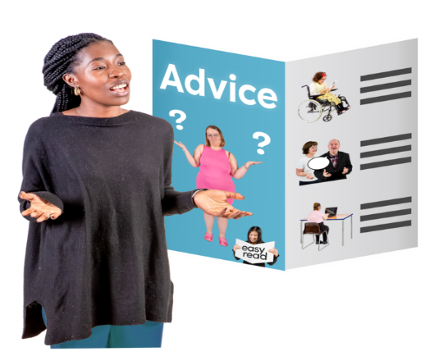 | They will provide advice about what you may be able to get help with.
 | They will also help you decide where to live.

Will I have an assessment?

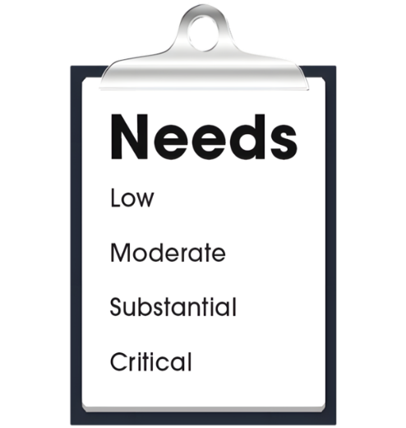  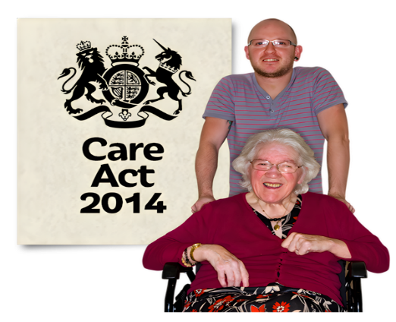 | An Assessment means finding out what someone needs so the right help and support can be given at the right time. In Adult services this is called a Care Act Assessment (2014). It will tell us if you have eligible needs.  A Care Act Assessment (2014) - A care act assessment is a meeting with you, to talk about what help and support you may need to live safe and well.  Eligible needs - Eligible needs means that a person needs some help and support with day-to-day things.
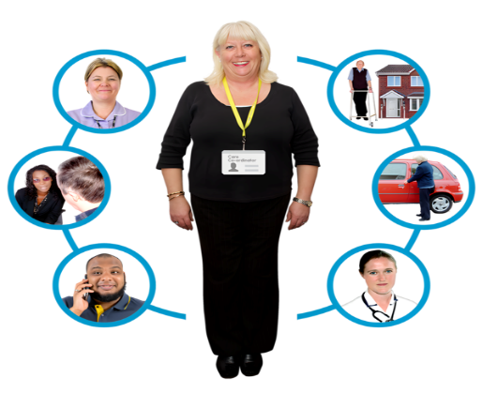 | The assessment helps us understand what support you might need and who can provide it. The Adult social worker will then develop a new Care Plan.  A Care Plan is a document that explains what support has been arranged to help you live safe and well.
What will I be asked in an assessment:

   | If you need help with things like  shopping  cooking.
 | If you need help with cleaning your home.
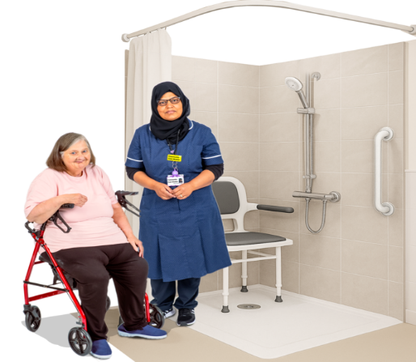 | If you need help with washing, bathing and dressing.
 | If you need help making a meal or eating a meal.

 | If you need help to share your views.
 | If you need help to get out and make friends.
 | If you go to school or college, or if you want to get a job
 | You will also have a financial assessment. This will be arranged by the Council to decide if you must pay towards your support.  Financial assessment – A Finance Officer will look at what money is coming in, going out, and any savings you may have. The Officer will see how much you can afford to pay towards your care and support.

Do I have to move house?

 | No – Not everyone would like to move out of their home.
 | You may be able to continue to live with your family.
 | You may wish to live with other people.
 | You may wish to live on your own.

Will I get any money?

 | When you turn 18 the money you get may change.
 | You may be entitled to benefits such as Personal independence payment (PIP) and Housing benefit to help pay for your rent if you are moving out of the family home.
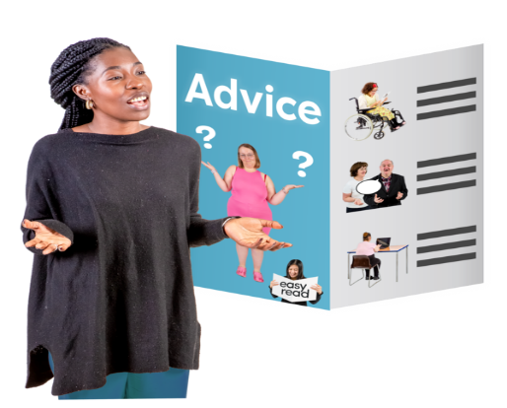 | You will be provided with help to see what you can get.

What will I have to pay for if I live on my own?

 | You will need money to pay for things such as the internet.
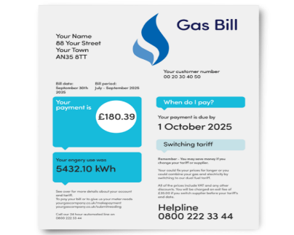 | You will need to pay for gas and electricity. These are called utilities.
 | You may have to pay towards your care and support.
 | You will need to pay for your own food and drinks if you move out of home.

Will I get a carer?

 | If you need help to look after yourself you may need a personal assistant (PA).
 | You may not want a carer but may need help to live independently. Your Adult social worker will talk to you about options.
 | You might already have a Personal Assistant (PA), and they may be able to stay with you as an adult.

Key words

Transition | Transition means to change from one thing to the next.
Assessment | Assessment means deciding what someone might need, such as what they can do and what they need support with.
Care Act Assessment | A care act assessment is a meeting to talk about what help and support a person needs to live safe and well.
Eligible Needs | Eligible needs mean someone needs help and support with day to day things.
Care Plan | A Care Plan is a document which explains what support has been arranged.
Personal independence payment (PIP) | This is money a person might get from the government to help with extra costs if they have a long term illness or disability.
Personal Assistant | A personal assistant is someone who can help you with daily tasks. They may be paid to help you.
Financial Assessment | A financial assessment for adult social care is when the council looks at the person’s income and savings to see how much the person can afford to pay towards their care and support.

More information can be found by accessing
https://www.informationnow.org.uk/article/moving-from-childrens-to-adults-social-care/
On this website you can find more information on each of the topics above.

